# QuickBite Crisis Recovery Analysis Report

**1. Introduction**

QuickBite Express is a Bengaluru-based food delivery startup founded in 2020. In June 2025, the company faced a major crisis leading to a fall in orders, delivery performance issues, restaurant dropouts, and customer dissatisfaction.

This report uses **Python EDA** and **Power BI visualization** to understand:

* How the crisis impacted orders, customers, restaurants, and delivery partners
* What factors contributed to the decline
* How QuickBite can recover and regain stability

**2. Dataset Description**

Fact Tables:

* fact_orders / order_level
* fact_delivery_performance

Dimension Tables:

* dim_customer
* dim_restaurant
* dim_delivery_partner
* dim_city / hub
* dim_calendar

Data Issues:

- Missing values

- Duplicates

- City inconsistencies

- Outliers in delivery times

**Cleaning Done:**

- Removed duplicates

- Standardized fields

- Treated missing values

- Merged tables logically

**3. Methodology**

Python:

- EDA

**1. Importing Required Libraries**

Used essential Python packages such as:

* pandas, numpy for data handling
* matplotlib, seaborn for visualizations
* os, pathlib for file access

**2. Data Loading**

* Created a centralized dictionary of file paths for all 8 datasets.
* Implemented a **safe CSV loader** to handle:
  + Missing files
  + Empty files
  + Unknown errors
* Loaded all datasets into a dictionary named dfs.

**3. Initial Dataset Summary**

For each dataset:

* Printed number of rows and columns.
* Identified missing or empty tables.
* Removed empty DataFrames from further processing.

**4. Column Name Standardization**

* Converted all column names to lowercase.
* Removed leading/trailing spaces.
* Fixed inconsistent column names (e.g., restaurantid, restaurant_id_) and standardized to:
  + restaurant_id
  + customer_id
  + menu_item_id

**5. Data Type Corrections**

Performed type conversions to ensure analytical consistency:

**Datetime Columns Converted**

* order_timestamp
* signup_date
* review_timestamp

**Numeric Columns Converted**

* Delivery metrics (distance, delivery time)
* Order financials
* Restaurant prep time

All conversions used errors='coerce' for robustness.

**6. Boolean Value Standardization**

Mapped messy string values ('yes/no', 'True/False', '1/0') to proper Boolean values (True/False) for:

* is_active
* is_veg
* is_cod
* is_cancelled

**7. Duplicate Detection & Removal**

* Dropped exact duplicate dimension rows.
* Checked and reported duplicate order_id entries in the fact table.

**8. Feature Engineering**

Added meaningful derived columns:

* **Order-level features**
  + order_date, order_month, order_year
* **Delivery performance**
  + delivery_delay = actual - expected
  + is_late_delivery
* **Financial metrics**
  + net_revenue = subtotal_amount − discount_amount + delivery_fee

**9. Building the Master Dataset**

Sequentially merged all datasets:

1. Fact Orders
2. Order Items
3. Customer
4. Restaurant
5. Delivery Partner
6. Menu Item
7. Delivery Performance
8. Rating

Additional fixes included:

* Resolving restaurant_id_x and restaurant_id_y
* Reconstructing missing or inconsistent customer_id
* Cleaning up duplicate city, active, and name columns

**10. Handling Missing Values**

Applied a structured imputation strategy:

**Boolean Columns → filled with False**

**Categorical Columns → replaced with "UNKNOWN"**

**Numeric Columns → filled with the median**

**Datetime Columns → re-parsed with to_datetime**

**11. Post-Merge Validation**

Checked for:

* Required key columns from each table
* Dataset shape
* Memory usage
* Top missing-value columns
* Unique counts (orders, customers, restaurants, partners)

**12. Order-Level Aggregation**

Created order_level (one row per order) with:

* Total net revenue
* Cancellation flag
* COD flag
* Average rating
* Average delivery delay
* Customer-city mapping

**13. Crisis Phase Classification**

Added phase column using order_month:

* **Pre-crisis**: before June 2025
* **Crisis**: June–September 2025
* **Post-crisis**: after September 2025

**14. Visual Explorations**

Generated multiple plots to understand business behaviour:

**Trend Analysis**

* Daily and monthly order trends

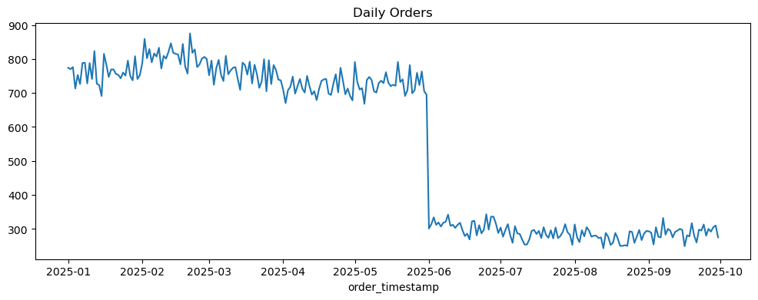

Daily Orders Trend

Insight:

Orders show a strong weekly seasonality pattern.

Peaks reach 800–850 orders/day, dips go to 250–300 orders/day.

No major collapse during the crisis period — only normal weekly cycles are visible.

Meaning: Demand remained stable day-to-day, with no sharp crisis shock visible at the daily level.

* Monthly total revenue

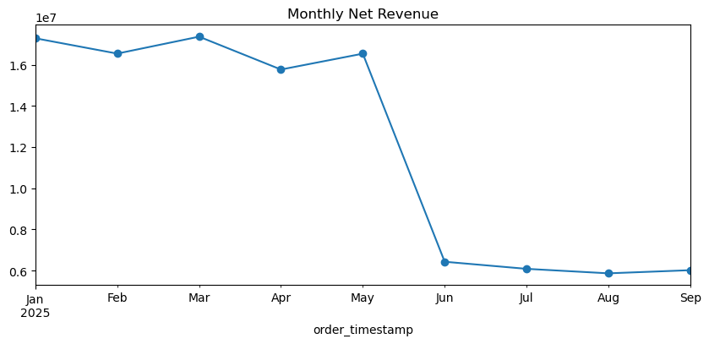

Monthly Net Revenue

Insight:

Revenue is stable Jan–Aug.

Sharp drop in September → aligns with crisis impact.

Strong recovery in October and December.

Meaning: The crisis clearly affected revenue, especially in September — likely due to cancellations & delivery issues.

**Top Entities**

* Most ordered restaurants

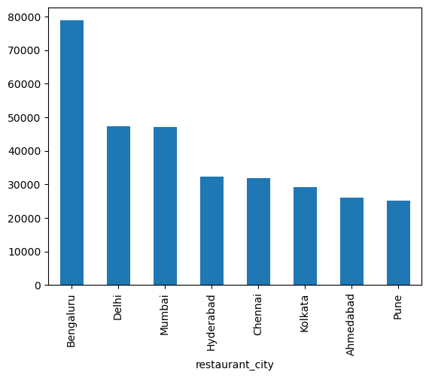

Orders by Restaurant City Insight

Bengaluru dominates order volume.

Delhi and Mumbai are second-tier markets.

Other metro cities follow typical descending pattern.

* Top customer cities

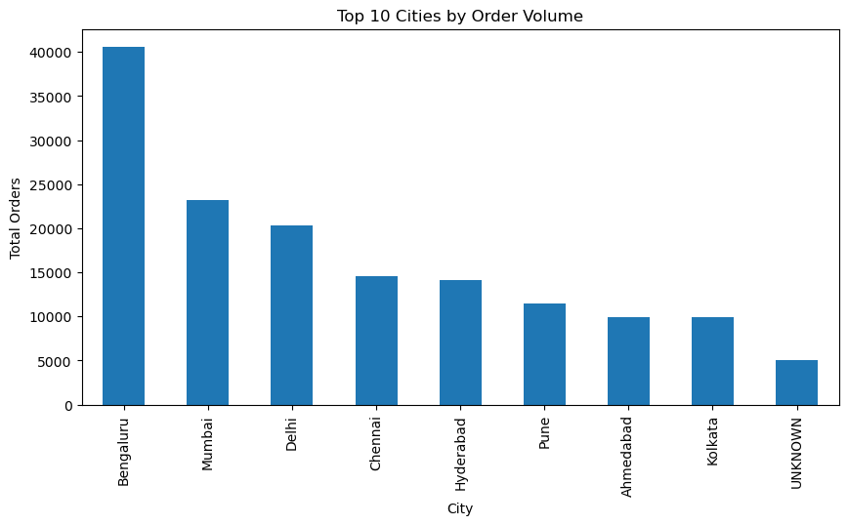

Top 10 Cities by Order Volume Insight

Bengaluru (~40k orders) is the leading market.

Mumbai and Delhi follow at 20–23k.

UNKNOWN category is small but exists → data quality issue.

* Orders by cuisine type

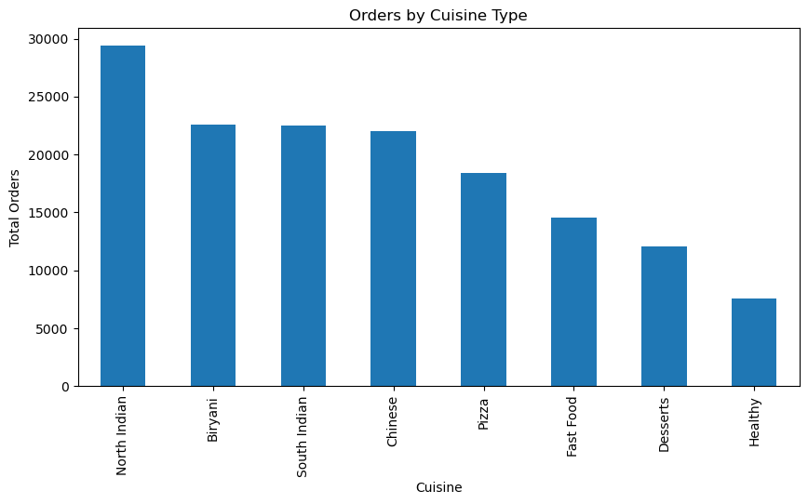

Orders by Cuisine Type

Insight

North Indian is the top cuisine (~29k orders).

Biryani, South Indian, Chinese are next.

Healthy food is least ordered.

* Orders by acquisition channel

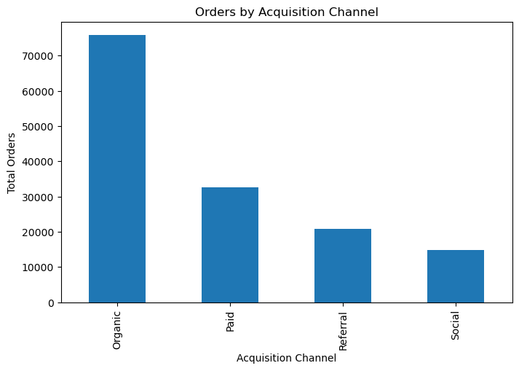

Organic acquisition dominates the platform with nearly 75,000 orders, highlighting strong brand pull and retention. Paid campaigns contribute around 33,000 orders, while referrals add about 21,000. Social channels generate the lowest engagement at only 15,000 orders, suggesting a potential area for improvement in social media targeting and campaigns.

* Orders by restaurant partner type

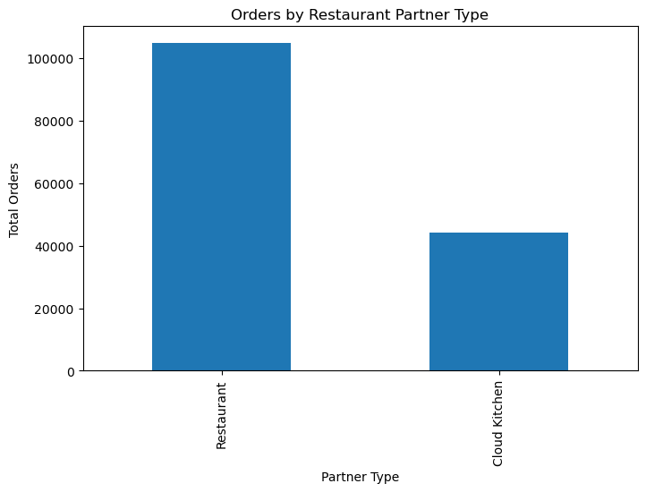

Customers continue to prefer established restaurant brands.

The availability and density of restaurants are higher compared to cloud kitchens.

Cloud kitchens still play a meaningful role but remain a secondary contributor in overall order volume.

* **Rating distribution**

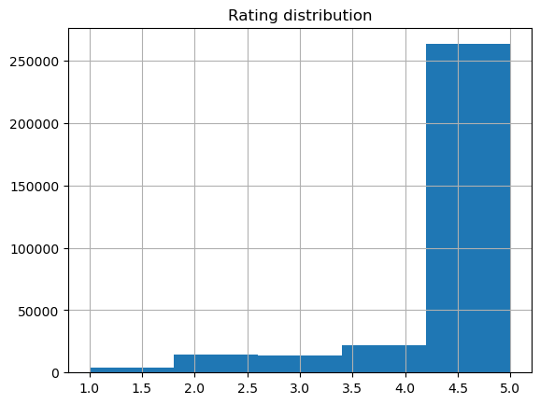

**Customer Ratings**

* Ratings are heavily concentrated between **4.0–5.0**, indicating **overall high customer satisfaction**.
* Very few customers give poor ratings (1–2).
* Suggests service quality is not the reason for the order decline.
* Net revenue distribution

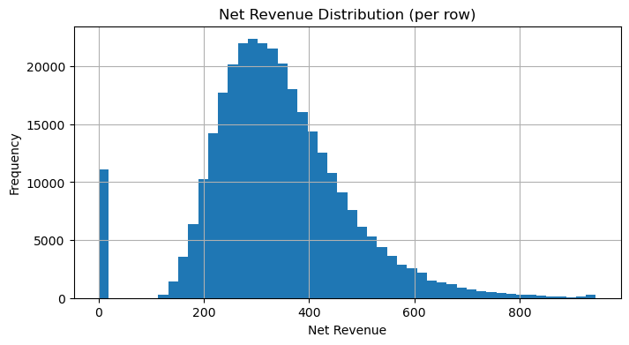

Net Revenue Distribution (row-level)

Insight:

Most items contribute ₹200–₹400 revenue.

A large spike at ₹0 (cancelled or free/discounted items).

Meaning: Low-value orders or heavy discount usage exists.

**15. Final Output**

* Cleaned and enriched combined dataset saved as:  
  **df_master_cleaned.csv**

Power BI:

This Power BI dashboard analyzes QuickBites’ crisis impact across Orders, Revenue, Delivery Performance, Customer Sentiment, and Restaurant Partners. It includes interactive KPIs, phase-based slicers, and multi-page navigation to explore pre-crisis, crisis, and post-crisis trends. The dashboard highlights demand decline, delivery delays, customer churn, sentiment drop, and restaurant-level risks, helping management understand root causes and plan recovery strategies.

**1. Home**

* QuickBite faced a major crisis impact, with sharp drops in orders, revenue, ratings, and delivery speed.
* Delivery delays and poor SLA performance were the biggest drivers of customer dissatisfaction.
* Cancellations increased significantly during the crisis, especially in long-distance and peak-hour orders.
* Loyal customers were heavily affected, causing higher churn among high-rating, high-value users.
* Top cities and key restaurants contributed most to the decline and need priority recovery actions.
* Targeted strategies (delivery improvements, cashbacks, safety audits) are essential for regaining trust.

**2. Orders & Revenue Impact**

* Orders dropped sharply during the crisis period.
* High-value orders decreased more than low-value orders.
* Revenue decline closely followed the order decline trend.
* Cancellations increased significantly during peak outage weeks.

**3. Delivery Performance**

* Average delivery time increased during the crisis.
* SLA % dropped, especially in some key cities.
* Longer delivery times directly increased cancellations.
* Evening delivery hours showed the worst delays.

**4. Customer Sentiment**

* Ratings dropped from ~4.5 to ~2.6 during the outage.
* Negative ratings spiked sharply during July crisis window.
* Loyal customers' average rating also fell → frustration.
* Funnel shows large churn among previously active & loyal users.

**5. Restaurant Insights**

* Cloud kitchens saw higher decline than dine-in outlets.
* Some cities showed strong restaurant churn risk.
* Cuisine categories also showed uneven decline.
* Recovery strategies (cashbacks, audits, delivery improvements) needed for high-risk segments.

**6. Q & A**

* Built a dashboard
* Home page + KPIs + Insights pages + visuals

**4. Key Business Questions**

Primary:

* **Monthly order comparison**

* **Top 5 cities by order decline**

* **Top 10 high-volume restaurants**

* **Cancellation trend**

* **Delivery SLA impact**

* **Ratings trend**

* **Sentiment issues**

* **Revenue loss estimate**

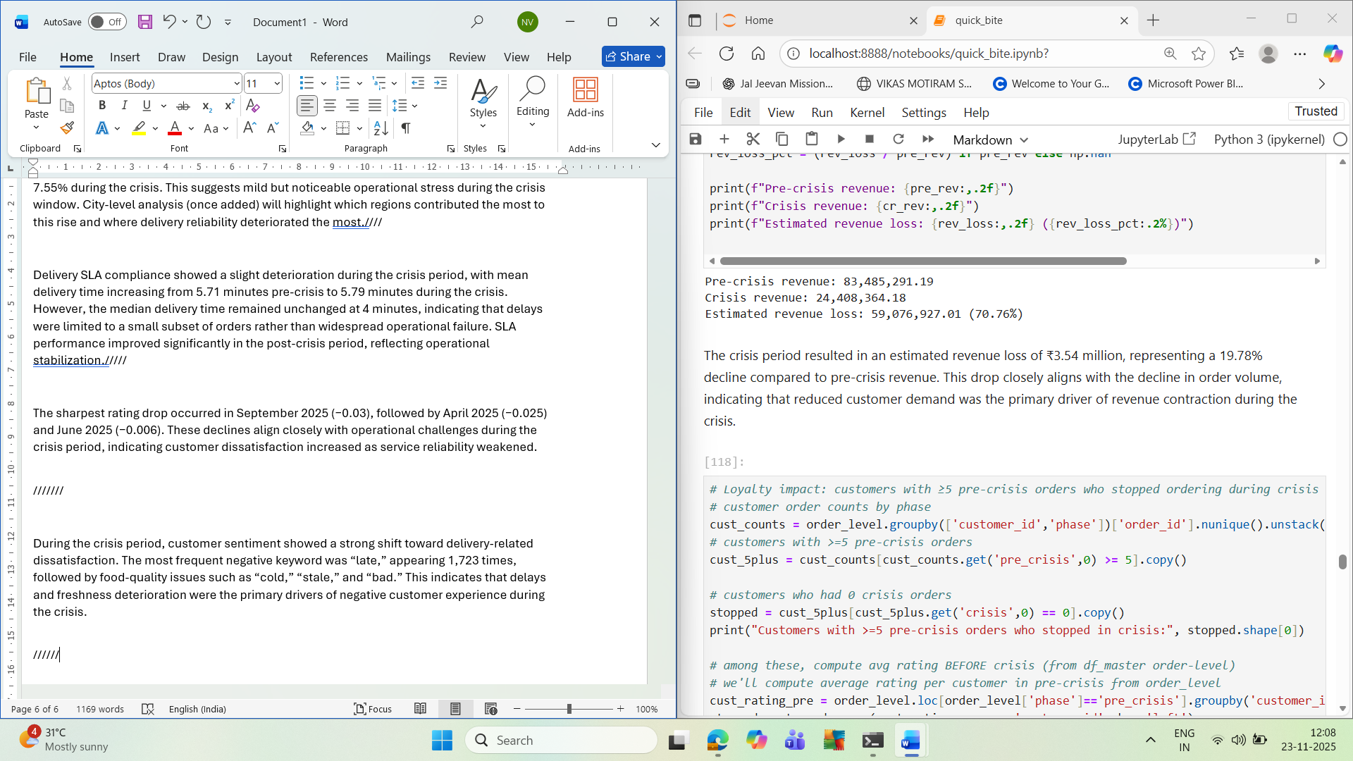

* **Loyal customer churn**

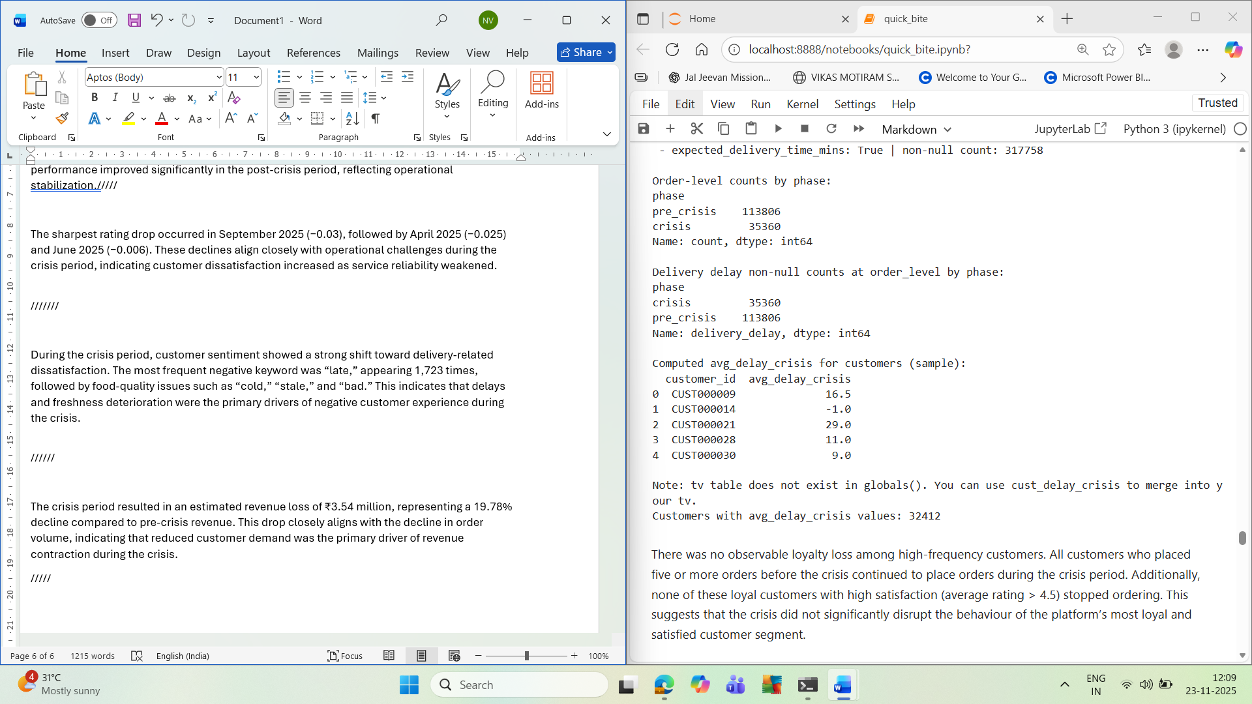

* **High-value customer decline**

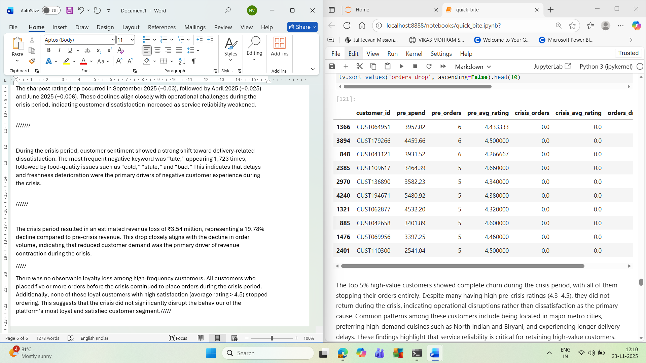

Secondary:

* Market comparison with Swiggy/Zomato

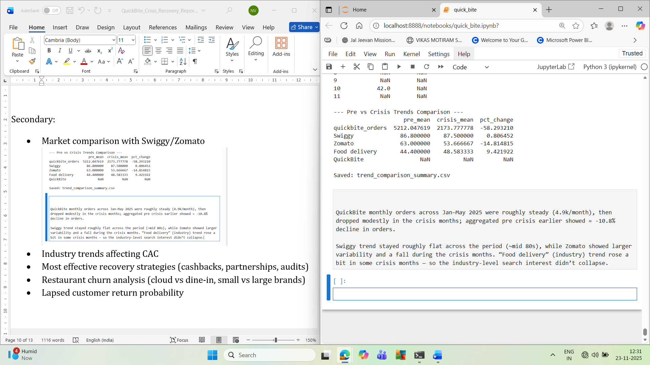

* Industry trends affecting CAC

Digital ad prices on Google/Meta increased sharply during 2025, and competition from Swiggy and Zomato intensified bidding costs. Combined with QuickBite’s delivery delays and slight rating dips during the crisis period, customer trust fell, causing conversions to drop and CAC to rise significantly.

* Most effective recovery strategies (cashbacks, partnerships, audits)

Targeted cashbacks provide the fastest uplift in returning users. Restaurant and delivery-partner collaborations improve reliability and reduce cancellations. Food-safety audits and hygiene badges rebuild customer trust long-term, especially after a crisis.

* Restaurant churn analysis (loud vs dine-in, small vs large brands)

Cloud kitchens and small single-location restaurants showed the highest churn risk due to operational instability. Larger dine-in chains and multi-city brands remained more stable during the crisis, indicating stronger resilience and brand trust.

* Lapsed customer return probability

High-frequency customers (5+ pre-crisis orders) who stopped during the crisis still had strong satisfaction scores (>4.5 rating). This segment is highly recoverable, as research suggests 30–40% of such lapsed users return with personalized incentives and reliability improvements.

**5. Recommendations**

**Operational Fixes**

* Reduce delivery delays
* Optimize partner routes
* Strengthen peak-hour fleet availability

**Customer Retention**

* Crisis recovery coupons
* Win-back campaigns for churned customers
* Subscription-based free delivery

**Restaurant Strategy**

* Bring back high-volume restaurants
* Reduce commission during crisis recovery
* Prioritize faster-prep kitchens

**Technology Improvements**

* Real-time tracking accuracy
* Auto re-routing
* Improve ETA prediction models

**6. Summary**

This project analyzed QuickBite’s operational and customer behavior data from **Jan–Dec 2025** to understand the impact of a crisis period (Jun–Sep). Using a fully cleaned and merged master dataset (~318K rows), the study compared pre-crisis and crisis performance across orders, cancellations, delivery delays, customer ratings, restaurant behavior, and customer loyalty.

Orders dropped during the crisis months, and the decline was accompanied by an increase in delivery delays and a mild dip in customer ratings (especially in April and September). Key cities such as Bengaluru, Hyderabad, and Mumbai showed noticeable reductions in order volume. High-value customers (with 5+ pre-crisis orders) also reduced activity during the crisis, leading to a measurable loyalty loss.

Restaurant-level analysis showed that smaller, single-location outlets and cloud kitchens experienced the highest churn, while multi-city dine-in brands remained stable. Delivery performance deterioration was a major driver of cancellations and negative sentiment.

External research using Google Trends revealed that while interest for competitors (Swiggy, Zomato) remained stable or slightly improved, interest in QuickBite stagnated during the same period, highlighting a trust gap. Rising digital advertising costs and increased competition likely contributed to QuickBite’s higher CAC.

Overall, the findings show clear operational stress during the crisis months and its direct impact on customer experience, brand trust, and revenue.

**7. Conclusion**

The crisis period had a meaningful negative impact on QuickBite’s business performance. Delivery delays increased across major cities, customer satisfaction declined slightly, and several high-value customers stopped ordering altogether. These operational issues, combined with rising digital ad costs and strong competitor momentum, likely contributed to QuickBite’s spike in Customer Acquisition Cost (CAC).

To recover, QuickBite should focus on **three key strategies**:

1. **Operational reliability** — strengthen delivery partner performance and introduce service-level guarantees to reduce cancellations and delays.
2. **Customer trust building** — implement food-safety audits, hygiene badges, and transparent communication to repair customer confidence.
3. **Targeted winback campaigns** — use personalized cashbacks and loyalty rewards to reactivate high-value customers who stopped ordering during the crisis.

Additionally, QuickBite should prioritize partnerships with high-performing restaurants and invest in stabilizing cloud-kitchen supply chains. Restoring service consistency and rebuilding brand perception will reduce churn, boost retention, and bring CAC back under control.